# Project Design Phase-I Solution Architecture

|  |  |
| --- | --- |
| Date | 07 NOVEMBER 2022 |
| Team ID | PNT2022TMID46280 |
| Project Name | Project - A Novel Method For Handwritten Digit  Recognition System |
| Maximum Marks | 4 Marks |

**Solution Architecture:**

Solution architecture is a complex process – with many sub-processes – that bridges the gap between business problems and technology solutions.

Handwriting recognition is one of the compelling research works going on because every individual in this world has their own style of writing. It is the capability of the computer to identify and understand handwritten digits or characters automatically. Because of the progress in the field of science and technology, everything is being digitalized to reduce human effort.

Hence, there comes a need for handwritten digit recognition in many real-time applications. Its goals are to:

* MNIST data set is widely used for this recognition process, and it has 70000 handwritten digits.
* We use Artificial neural networks to train these images and build a deep learning model.
* Web application is created where the user can upload an image of a handwritten digit.
* This image is analysed by the model and the detected result is returned on to UI.

# Example - Solution Architecture Diagram:

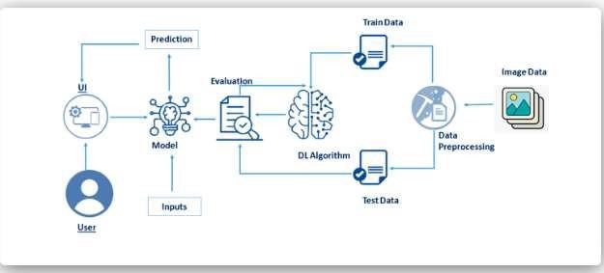

*Figure 1: Architecture and data flow of the Handwritten Digit Recognition System.*

**Reference:**

[**https://careereducation.smartinternz.com/saas-guided-project/3/a-novel-method-for-**](https://careereducation.smartinternz.com/saas-guided-project/3/a-novel-method-for-handwritten-digit-recognition-system)[**handwritten-digit-recognition-system**](https://careereducation.smartinternz.com/saas-guided-project/3/a-novel-method-for-handwritten-digit-recognition-system)